모바일프로그래밍 과제14 컴퓨터소프트웨어공학과 2-YA 20202296 전채린

CustomerManagement 고객관리시스템

[소스코드]

activity_main.xml

<?xml version="1.0" encoding="utf-8"?>  
<LinearLayout xmlns:android="http://schemas.android.com/apk/res/android"  
 xmlns:app="http://schemas.android.com/apk/res-auto"  
 xmlns:tools="http://schemas.android.com/tools"  
 android:layout_width="match_parent"  
 android:layout_height="match_parent"  
 android:orientation="vertical"  
 android:gravity="center_horizontal"  
 tools:context=".MainActivity">  
  
 <ImageView  
 android:layout_width="wrap_content"  
 android:layout_height="wrap_content"  
 android:padding="40dp"  
 android:src="@drawable/fig1" />  
 <Button  
 android:layout_width="match_parent"  
 android:layout_height="wrap_content"  
 android:id="@+id/button1"  
 android:padding="20dp"  
 android:text="고객등록" />  
 <Button  
 android:layout_width="match_parent"  
 android:layout_height="wrap_content"  
 android:id="@+id/button2"  
 android:padding="20dp"  
 android:text="고객현황" />  
</LinearLayout>

customerlist.xml

<?xml version="1.0" encoding="utf-8"?>  
<LinearLayout xmlns:android="http://schemas.android.com/apk/res/android"  
 xmlns:tools="http://schemas.android.com/tools"  
 android:orientation="vertical"  
 android:layout_width="match_parent"  
 android:layout_height="match_parent"  
 tools:context=".CustomerlistActivity">  
 <TextView  
 android:layout_width="match_parent"  
 android:layout_height="wrap_content"  
 android:background="#8D8D8D"  
 android:textColor="#ffffff"  
 android:text="고객등록리스트" />  
 <ListView  
 android:layout_width="match_parent"  
 android:layout_height="wrap_content"  
 android:id="@+id/listView1" />  
</LinearLayout>

jasehi.xml

<?xml version="1.0" encoding="utf-8"?>  
<?xml version="1.0" encoding="utf-8"?>  
<LinearLayout xmlns:android="http://schemas.android.com/apk/res/android"  
 xmlns:app="http://schemas.android.com/apk/res-auto"  
 xmlns:tools="http://schemas.android.com/tools"  
 android:layout_width="match_parent"  
 android:layout_height="match_parent"  
 android:orientation="vertical"  
 tools:context=".JasehiActivity">  
 <TextView  
 android:layout_width="match_parent"  
 android:layout_height="wrap_content"  
 android:textSize="20sp"  
 android:textColor="#0048FF"  
 android:text="고객 상세 설명" />  
 <TextView  
 android:layout_width="match_parent"  
 android:layout_height="wrap_content"  
 android:id="@+id/jCustId"  
 android:text="고객번호" />  
 <TextView  
 android:layout_width="match_parent"  
 android:layout_height="wrap_content"  
 android:id="@+id/jName"  
 android:text="이름/성별" />  
 <TextView  
 android:layout_width="match_parent"  
 android:layout_height="wrap_content"  
 android:id="@+id/jPhone"  
 android:text="연락처" />  
 <TextView  
 android:layout_width="match_parent"  
 android:layout_height="wrap_content"  
 android:id="@+id/jEmail"  
 android:text="이메일" />  
 <TextView  
 android:layout_width="match_parent"  
 android:layout_height="wrap_content"  
 android:id="@+id/jCity"  
 android:text="지역" />  
 <TextView  
 android:layout_width="match_parent"  
 android:layout_height="wrap_content"  
 android:id="@+id/jGrade"  
 android:text="고객등급" />  
</LinearLayout>

register.xml

<?xml version="1.0" encoding="utf-8"?>  
<LinearLayout xmlns:android="http://schemas.android.com/apk/res/android"  
 xmlns:tools="http://schemas.android.com/tools"  
 android:orientation="vertical"  
 android:layout_width="match_parent"  
 android:layout_height="match_parent"  
 tools:context=".RegisterActivity">  
 <TextView  
 android:layout_width="match_parent"  
 android:layout_height="wrap_content"  
 android:background="#8D8D8D"  
 android:textColor="#ffffff"  
 android:text="고객등록" />  
 <LinearLayout  
 android:layout_width="wrap_content"  
 android:layout_height="wrap_content">  
  
 <TextView  
 android:layout_width="60dp"  
 android:layout_height="wrap_content"  
 android:text="성명" />  
 <EditText  
 android:layout_width="match_parent"  
 android:layout_height="wrap_content"  
 android:id="@+id/edName"  
 android:hint="이름을 입력하시오" />  
 </LinearLayout>  
 <LinearLayout  
 android:layout_width="match_parent"  
 android:layout_height="wrap_content"  
 android:orientation="horizontal">  
 <TextView  
 android:layout_width="60dp"  
 android:layout_height="wrap_content" />  
 <RadioGroup  
 android:layout_width="wrap_content"  
 android:layout_height="wrap_content"  
 android:orientation="horizontal">  
 <RadioButton  
 android:layout_width="wrap_content"  
 android:layout_height="wrap_content"  
 android:id="@+id/rb1"  
 android:text="남"  
 android:checked="true" />  
 <RadioButton  
 android:layout_width="wrap_content"  
 android:layout_height="wrap_content"  
 android:id="@+id/rb2"  
 android:text="여" />  
 </RadioGroup>  
 </LinearLayout>  
 <LinearLayout  
 android:layout_width="match_parent"  
 android:layout_height="wrap_content"  
 android:orientation="horizontal" >  
 <TextView  
 android:layout_width="60dp"  
 android:layout_height="wrap_content"  
 android:text="휴대폰" />  
 <EditText  
 android:layout_width="match_parent"  
 android:layout_height="wrap_content"  
 android:id="@+id/edPhone"  
 android:hint="휴대폰 번호를 입력하시오" />  
 </LinearLayout>  
 <LinearLayout  
 android:layout_width="match_parent"  
 android:layout_height="wrap_content"  
 android:orientation="horizontal" >  
 <TextView  
 android:layout_width="60dp"  
 android:layout_height="wrap_content"  
 android:text="지역" />  
 <EditText  
 android:layout_width="match_parent"  
 android:layout_height="wrap_content"  
 android:id="@+id/edCity"  
 android:hint="시도를 입력하시오" />  
 </LinearLayout>  
 <LinearLayout  
 android:layout_width="match_parent"  
 android:layout_height="wrap_content"  
 android:orientation="horizontal" >  
 <TextView  
 android:layout_width="60dp"  
 android:layout_height="wrap_content"  
 android:text="이메일" />  
 <EditText  
 android:layout_width="match_parent"  
 android:layout_height="wrap_content"  
 android:id="@+id/edEmail"  
 android:hint="email을 입력하시오" />  
 </LinearLayout>  
 <LinearLayout  
 android:layout_width="match_parent"  
 android:layout_height="wrap_content"  
 android:orientation="horizontal" >  
 <TextView  
 android:layout_width="60dp"  
 android:layout_height="wrap_content"  
 android:text="고객등급" />  
 <Spinner  
 android:layout_width="match_parent"  
 android:layout_height="wrap_content"  
 android:id="@+id/spGrade" />  
 </LinearLayout>  
  
 <Button  
 android:layout_width="match_parent"  
 android:layout_height="wrap_content"  
 android:id="@+id/rButton1"  
 android:text="등록" />  
</LinearLayout>

rowitem.xml

<?xml version="1.0" encoding="utf-8"?>  
<LinearLayout xmlns:android="http://schemas.android.com/apk/res/android"  
 android:orientation="horizontal"  
 android:layout_width="match_parent"  
 android:layout_height="match_parent">  
 <ImageView  
 android:layout_width="125dp"  
 android:layout_height="125dp"  
 android:id="@+id/itemImage"  
 android:src="@drawable/fig1" />  
 <LinearLayout  
 android:layout_width="wrap_content"  
 android:layout_height="wrap_content"  
 android:layout_weight="8"  
 android:orientation="vertical" >  
 <TextView  
 android:layout_width="wrap_content"  
 android:layout_height="wrap_content"  
 android:id="@+id/itemNo"  
 android:text="고객번호" />  
 <TextView  
 android:layout_width="wrap_content"  
 android:layout_height="wrap_content"  
 android:id="@+id/itemName"  
 android:textSize="20sp"  
 android:textColor="#ff0000"  
 android:text="이름/성별" />  
 <TextView  
 android:layout_width="wrap_content"  
 android:layout_height="wrap_content"  
 android:id="@+id/itemPhone"  
 android:textSize="15sp"  
 android:textColor="#007BFF"  
 android:text="연락처" />  
 <TextView  
 android:layout_width="wrap_content"  
 android:layout_height="wrap_content"  
 android:id="@+id/itemEmail"  
 android:text="이메일" />  
 <TextView  
 android:layout_width="wrap_content"  
 android:layout_height="wrap_content"  
 android:id="@+id/itemCity"  
 android:text="지역" />  
 <TextView  
 android:layout_width="wrap_content"  
 android:layout_height="wrap_content"  
 android:id="@+id/itemGrade"  
 android:text="고객등급" />  
 </LinearLayout>  
  
</LinearLayout>

AndroidManifest.xml

<?xml version="1.0" encoding="utf-8"?>  
<manifest xmlns:android="http://schemas.android.com/apk/res/android"  
 package="aca.hankook.customermanagement">  
  
 <application  
 android:allowBackup="true"  
 android:icon="@mipmap/ic_launcher"  
 android:label="@string/app_name"  
 android:roundIcon="@mipmap/ic_launcher_round"  
 android:supportsRtl="true"  
 android:theme="@style/AppTheme">  
 <activity android:name=".CustomerlistActivity"></activity>  
 <activity android:name=".RegisterActivity"></activity>  
 <activity android:name=".JasehiActivity"></activity>  
 <activity android:name=".MainActivity">  
 <intent-filter>  
 <action android:name="android.intent.action.MAIN" />  
  
 <category android:name="android.intent.category.LAUNCHER" />  
 </intent-filter>  
 </activity>  
 </application>  
  
</manifest>

MainActivity.kt

package aca.hankook.customermanagement  
  
import android.content.Intent  
import androidx.appcompat.app.AppCompatActivity  
import android.os.Bundle  
import kotlinx.android.synthetic.main.activity_main.*  
  
class MainActivity : AppCompatActivity() {  
  
 override fun onCreate(savedInstanceState: Bundle?) {  
 super.onCreate(savedInstanceState)  
 setContentView(R.layout.*activity_main*)  
  
 button1.setOnClickListener **{** var intent1 = Intent(*applicationContext*, RegisterActivity::class.*java*)  
 startActivity(intent1)  
 **}** button2.setOnClickListener **{** var intent1 = Intent(*applicationContext*, CustomerlistActivity::class.*java*)  
 startActivity(intent1)  
 **}** }  
}

CustomerC.kt

package aca.hankook.customermanagement  
  
class CustomerC (var custId : Int, var name : String, var sex : String, var phone : String, var email : String, var city : String, var grade : String) {  
}

CustomerlistActivity.kt

package aca.hankook.customermanagement  
  
import android.annotation.SuppressLint  
import android.content.Intent  
import android.database.Cursor  
import android.database.sqlite.SQLiteDatabase  
import android.os.Bundle  
import android.widget.Toast  
import androidx.appcompat.app.AppCompatActivity  
import kotlinx.android.synthetic.main.customerlist.*  
  
@SuppressLint("Registered")  
class CustomerlistActivity : AppCompatActivity() {  
 override fun onCreate(savedInstanceState: Bundle?) {  
 super.onCreate(savedInstanceState)  
 setContentView(R.layout.customerlist)  
 var custList : ArrayList<CustomerC> = arrayListOf()  
 var myHelper : MyDBHelper = MyDBHelper(this)  
  
 var sqlDB: SQLiteDatabase = myHelper.readableDatabase  
 var cursor : Cursor = sqlDB.rawQuery("select * from customerTBL", null)  
 while(cursor.moveToNext()) {  
 custList.add(CustomerC(cursor.getInt(0), cursor.getString(1), cursor.getString(2),  
 cursor.getString(3), cursor.getString(4), cursor.getString(5), cursor.getString(6)))  
 }  
 cursor.close()  
 sqlDB.close()  
  
 var adapter1 = ListViewAdapter(custList)  
 listView1.adapter = adapter1  
 listView1.setOnItemClickListener **{** adapterView, view, i, l **->** Toast.makeText(applicationContext, "선택 " + custList.get(i).name, Toast.LENGTH_LONG).show()  
  
 var intent1 = Intent(applicationContext, JasehiActivity::class.java)  
  
 intent1.putExtra("custId", custList.get(i).custId)  
 intent1.putExtra("name", custList.get(i).name)  
 intent1.putExtra("sex", custList.get(i).sex)  
 intent1.putExtra("phone", custList.get(i).phone)  
 intent1.putExtra("email", custList.get(i).email)  
 intent1.putExtra("city", custList.get(i).city)  
 intent1.putExtra("grade", custList.get(i).grade)  
 startActivity(intent1)  
 **}** }  
  
}

JasehiActivity.kt

package aca.hankook.customermanagement  
  
import android.content.Intent  
import androidx.appcompat.app.AppCompatActivity  
import android.os.Bundle  
import kotlinx.android.synthetic.main.jasehi.*  
  
class JasehiActivity : AppCompatActivity() {  
  
 override fun onCreate(savedInstanceState: Bundle?) {  
 super.onCreate(savedInstanceState)  
 setContentView(R.layout.jasehi)  
  
 var intent1 : Intent = intent  
  
 var custId : Int? = intent1.getIntExtra( "custId", 0)  
 var name : String? = intent1.getStringExtra("name")  
 var sex : String? = intent1.getStringExtra("sex")  
 var phone : String? = intent1.getStringExtra("phone")  
 var email : String? = intent1.getStringExtra("email")  
 var city : String? = intent1.getStringExtra("city")  
 var grade : String? = intent1.getStringExtra("grade")  
  
 jCustId.text = "고객번호: " + custId  
 jName.text = "이름/성별: " + name + "/" + sex  
 jPhone.text = "고객번호: " + phone  
 jEmail.text = "고객번호: " + email  
 jCity.text = "고객번호: " + city  
 jGrade.text = "고객번호: " + grade  
 }  
}

ListViewAdapter.kt

package aca.hankook.customermanagement  
  
import android.view.View  
import android.view.ViewGroup  
import android.widget.BaseAdapter  
import kotlinx.android.synthetic.main.rowitem.view.*  
  
class ListViewAdapter(var custList: ArrayList<CustomerC>) : BaseAdapter() {  
 override fun getView(position: Int, view: View?, parent: ViewGroup?): View {  
 var rowItemView : View? = view  
 if(rowItemView == null) {  
 rowItemView = View.inflate(parent?.*context*, R.layout.*rowitem*, null)  
 }  
 val cust1 : CustomerC = custList[position]  
 var sajinResid : Int = parent!!.*resources*.getIdentifier("aca.hankook.customermanagement:" + "drawable/" + "s" + cust1.custId.toString(),  
 null, null)  
 rowItemView!!.itemImage.setImageResource(sajinResid)  
 rowItemView.itemNo.*text* = "고객번호: " + cust1.custId  
 rowItemView.itemName.*text* = "이름/성별: " + cust1.name + "/" + cust1.sex  
 rowItemView.itemPhone.*text* = "연락처: " + cust1.phone  
 rowItemView.itemEmail.*text* = "이메일: " + cust1.email  
 rowItemView.itemCity.*text* = "지역: " + cust1.city  
 rowItemView.itemGrade.*text* = "고객등급: " + cust1.grade  
  
 return rowItemView  
 }  
  
 override fun getItem(p0: Int): Any {  
 return custList[p0]  
 }  
  
 override fun getItemId(p0: Int): Long {  
 return p0.toLong()  
 }  
  
 override fun getCount(): Int {  
 return custList.size  
 }  
}

MyDBHelper.kt

package aca.hankook.customermanagement  
  
import android.content.Context  
import android.database.sqlite.SQLiteDatabase  
import android.database.sqlite.SQLiteOpenHelper  
  
class MyDBHelper (var context : Context) : SQLiteOpenHelper(context, "customerDB", null, 1) {  
 override fun onCreate(p0: SQLiteDatabase?) {  
 var tableCreSql = "create table customerTBL ( custId integer primary Key autoincrement, name varchar(20), sex varchar(20), phone varchar(20), email varchar(50), city varchar(20), grade varchar(20) );"  
 p0!!.execSQL(tableCreSql)  
 p0.execSQL("insert into customerTBL(name, sex, phone, email, city, grade) values('홍길동', '남', '010-1111-1111', '1@naver.com', '서울', 'VIP고객');")  
 p0.execSQL("insert into customerTBL(name, sex, phone, email, city, grade) values('배수지', '여', '010-2222-2222', '2@naver.com', '서울', 'VIP고객');")  
 p0.execSQL("insert into customerTBL(name, sex, phone, email, city, grade) values('한지민', '여', '010-3333-3333', '3@naver.com', '경기', 'VIP고객');")  
 p0.execSQL("insert into customerTBL(name, sex, phone, email, city, grade) values('남주혁', '남', '010-4444-4444', '4@naver.com', '인천', 'VIP고객');")  
 p0.execSQL("insert into customerTBL(name, sex, phone, email, city, grade) values('조정석', '남', '010-5555-5555', '5@naver.com', '부산', 'VIP고객');")  
 p0.execSQL("insert into customerTBL(name, sex, phone, email, city, grade) values('유연석', '남', '010-6666-6666', '6@naver.com', '대구', 'VIP고객');")  
 p0.execSQL("insert into customerTBL(name, sex, phone, email, city, grade) values('정경호', '남', '010-7777-7777', '7@naver.com', '대전', 'VIP고객');")  
 p0.execSQL("insert into customerTBL(name, sex, phone, email, city, grade) values('양석형', '남', '010-8888-8888', '8@naver.com', '강원', 'VIP고객');")  
 p0.execSQL("insert into customerTBL(name, sex, phone, email, city, grade) values('전미도', '여', '010-9999-9999', '9@naver.com', '대전', 'VIP고객');")  
 }  
  
 override fun onUpgrade(p0: SQLiteDatabase?, p1: Int, p2: Int) {  
 p0!!.execSQL("drop table if exists customerTBL")  
 onCreate(p0)  
 }  
}

RegisterActivity.kt

package aca.hankook.customermanagement  
  
import android.database.sqlite.SQLiteDatabase  
import android.os.Bundle  
import android.widget.ArrayAdapter  
import android.widget.Toast  
import androidx.appcompat.app.AppCompatActivity  
import kotlinx.android.synthetic.main.register.*  
  
class RegisterActivity : AppCompatActivity() {  
 override fun onCreate(savedInstanceState: Bundle?) {  
 super.onCreate(savedInstanceState)  
 setContentView(R.layout.*register*)  
  
 var grades = *arrayOf*("VIP고객", "GOLD고객", "SILVER고객")  
 var adapter1 : ArrayAdapter<String>  
 adapter1 = ArrayAdapter(this, android.R.layout.*simple_spinner_item*, grades)  
 spGrade.*adapter* = adapter1  
  
 rButton1.setOnClickListener **{** var name: String = edName.*text*.toString()  
 var sex = ""  
 if (rb1.*isChecked*) {  
 sex = "남"  
 } else {  
 sex = "여"  
 }  
 var phone: String = edPhone.*text*.toString()  
 var email: String = edEmail.*text*.toString()  
 var city: String = edCity.*text*.toString()  
 var grade : String = spGrade.*selectedItem*.toString()  
 var myHelper: MyDBHelper = MyDBHelper(this)  
 var sqlDB: SQLiteDatabase = myHelper.*writableDatabase* var insertSql: String =  
 "insert into customerTBL(name, sex, phone, email, city, grade) values ('" + name + "', '" + sex + "', '" + phone + "', '" + email + "', '" + city + "', '" + grade + "')"  
 sqlDB.execSQL(insertSql)  
  
 Toast.makeText(*applicationContext*, "insert ok " + name, Toast.*LENGTH_LONG*).show()  
 sqlDB.close()  
 **}** }  
}

[실행결과]

1) 초기화면

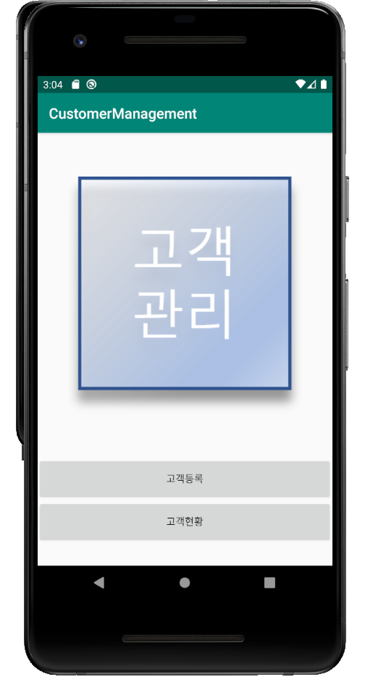

2) 고객등록 화면

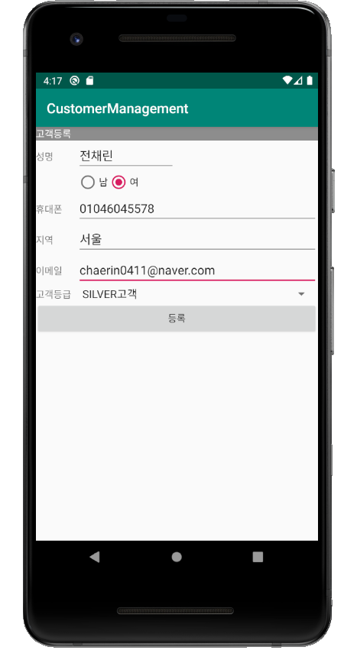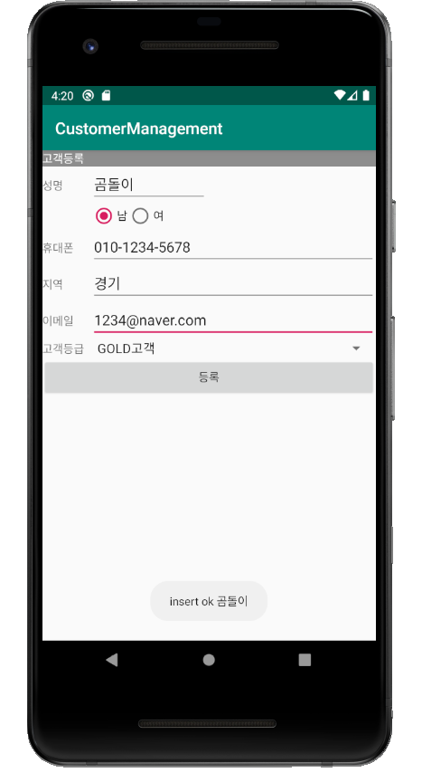

3) 고객현황(고객등록리스트) 화면

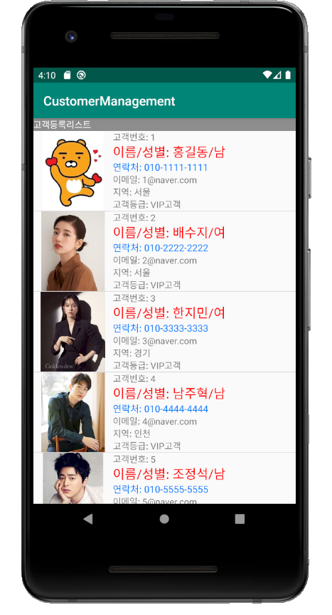 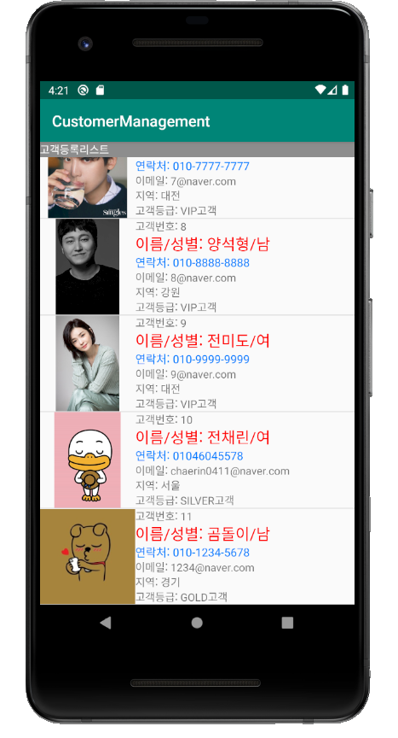

4) 고객 상세 설명 화면

